Linux下spi驱动开发

一、概述
基于子系统去开发驱动程序已经是linux内核中普遍的做法了。前面写过基于I2C子系统的驱动开发。本文介绍另外一种常用总线SPI的开发方法。SPI子系统的开发和I2C有很多的相似性，大家可以对比学习。本主题分为两个部分叙述，第一部分介绍基于SPI子系统开发的理论框架；第二部分以华清远见教学平台FS_S5PC100上的M25P10芯片为例（内核版本2.6.29），编写一个SPI驱动程序实例。

二、SPI总线协议简介
介绍驱动开发前，需要先熟悉下SPI通讯协议中的几个关键的地方，后面在编写驱动时，需要考虑相关因素。
SPI总线由MISO（串行数据输入）、MOSI（串行数据输出）、SCK（串行移位时钟）、CS（使能信号）4个信号线组成。如FS_S5PC100上的M25P10芯片接线为：
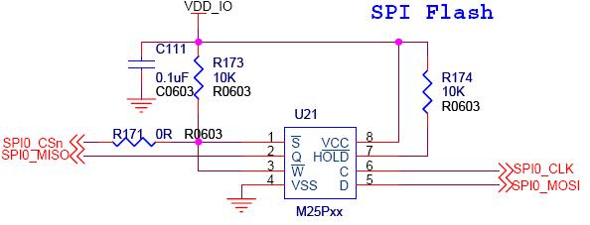
上图中M25P10的D脚为它的数据输入脚，Q为数据输出脚，C为时钟脚。
SPI常用四种数据传输模式，主要差别在于：输出串行同步时钟极性（CPOL）和相位（CPHA）可以进行配置。如果CPOL= 0，串行同步时钟的空闲状态为低电平；如果CPOL= 1，串行同步时钟的空闲状态为高电平。如果CPHA= 0，在串行同步时钟的前沿（上升或下降）数据被采样；如果CPHA = 1，在串行同步时钟的后沿（上升或下降）数据被采样。
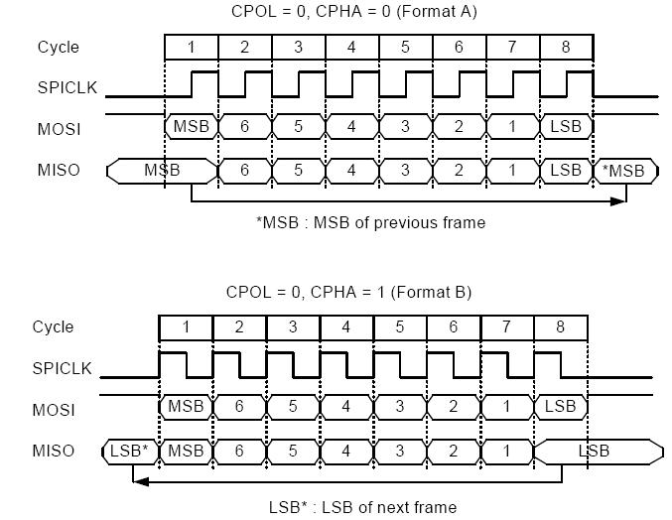
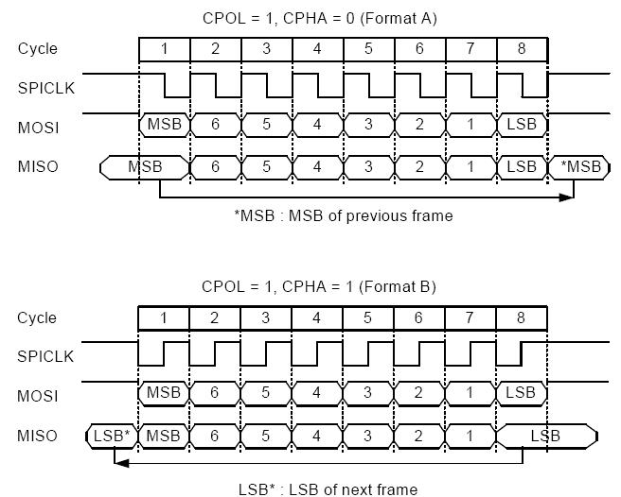
这四种模式中究竟选择哪种模式取决于设备。如M25P10的手册中明确它可以支持的两种模式为：CPOL=0 CPHA=0 和 CPOL=1 CPHA=1
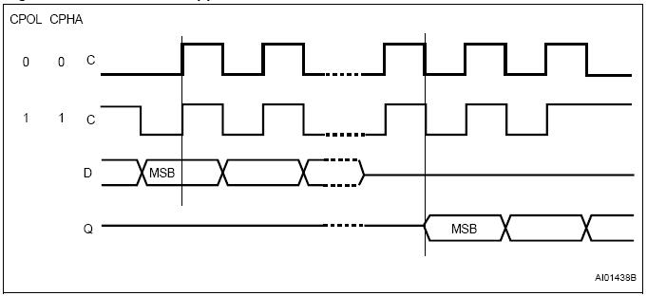

三、linux下SPI驱动开发
首先明确SPI驱动层次，如下图：
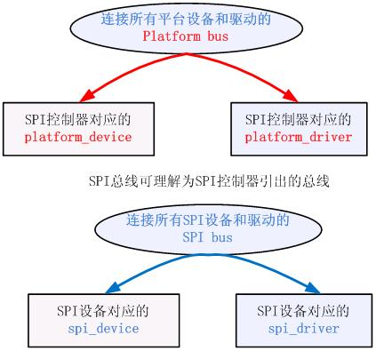
我们以上面的这个图为思路

1、 Platform bus
Platform bus对应的结构是platform_bus_type，这个内核开始就定义好的。我们不需要定义。

2、Platform_device
SPI控制器对应platform_device的定义方式，同样以S5PC100中的SPI控制器为例，参看arch/arm/plat-s5pc1xx/dev-spi.c文件
structplatform_device s3c_device_spi0 = {
.name ="s3c64xx-spi", //名称，要和Platform_driver匹配
.id =0, //第0个控制器，S5PC100中有3个控制器
.num_resources =ARRAY_SIZE(s5pc1xx_spi0_resource),//占用资源的种类
.resource =s5pc1xx_spi0_resource,//指向资源结构数组的指针
.dev= {
.dma_mask = &spi_dmamask, //dma寻址范围
.coherent_dma_mask = DMA_BIT_MASK(32), //可以通过关闭cache等措施保证一致性的dma寻址范围
.platform_data= &s5pc1xx_spi0_pdata,//特殊的平台数据，参看后文
},
};
static structs3c64xx_spi_cntrlr_info s5pc1xx_spi0_pdata= {
.cfg_gpio = s5pc1xx_spi_cfg_gpio, //用于控制器管脚的IO配置
.fifo_lvl_mask = 0x7f,
.rx_lvl_offset = 13,
};
static int s5pc1xx_spi_cfg_gpio(structplatform_device *pdev)
{
switch (pdev->id) {
case 0:
s3c_gpio_cfgpin(S5PC1XX_GPB(0),S5PC1XX_GPB0_SPI_MISO0);
s3c_gpio_cfgpin(S5PC1XX_GPB(1),S5PC1XX_GPB1_SPI_CLK0);
s3c_gpio_cfgpin(S5PC1XX_GPB(2),S5PC1XX_GPB2_SPI_MOSI0);
s3c_gpio_setpull(S5PC1XX_GPB(0),S3C_GPIO_PULL_UP);
s3c_gpio_setpull(S5PC1XX_GPB(1),S3C_GPIO_PULL_UP);
s3c_gpio_setpull(S5PC1XX_GPB(2),S3C_GPIO_PULL_UP);
break;
case 1:
s3c_gpio_cfgpin(S5PC1XX_GPB(4),S5PC1XX_GPB4_SPI_MISO1);
s3c_gpio_cfgpin(S5PC1XX_GPB(5),S5PC1XX_GPB5_SPI_CLK1);
s3c_gpio_cfgpin(S5PC1XX_GPB(6),S5PC1XX_GPB6_SPI_MOSI1);
s3c_gpio_setpull(S5PC1XX_GPB(4),S3C_GPIO_PULL_UP);
s3c_gpio_setpull(S5PC1XX_GPB(5),S3C_GPIO_PULL_UP);
s3c_gpio_setpull(S5PC1XX_GPB(6),S3C_GPIO_PULL_UP);
break;
case 2:
s3c_gpio_cfgpin(S5PC1XX_GPG3(0),S5PC1XX_GPG3_0_SPI_CLK2);
s3c_gpio_cfgpin(S5PC1XX_GPG3(2),S5PC1XX_GPG3_2_SPI_MISO2);
s3c_gpio_cfgpin(S5PC1XX_GPG3(3), S5PC1XX_GPG3_3_SPI_MOSI2);
s3c_gpio_setpull(S5PC1XX_GPG3(0),S3C_GPIO_PULL_UP);
s3c_gpio_setpull(S5PC1XX_GPG3(2),S3C_GPIO_PULL_UP);
s3c_gpio_setpull(S5PC1XX_GPG3(3),S3C_GPIO_PULL_UP);
break;
default:
dev_err(&pdev->dev, "InvalidSPI Controller number!");
return -EINVAL;
}

3、Platform_driver
再看platform_driver，参看drivers/spi/spi_s3c64xx.c文件
static structplatform_driver s3c64xx_spi_driver = {
.driver= {
.name = "s3c64xx-spi", //名称，和platform_device对应
.owner= THIS_MODULE,
},
.remove= s3c64xx_spi_remove,
.suspend= s3c64xx_spi_suspend,
.resume= s3c64xx_spi_resume,
};
platform_driver_probe(&s3c64xx_spi_driver,s3c64xx_spi_probe)；//注册s3c64xx_spi_driver
和平台中注册的platform_device匹配后，调用s3c64xx_spi_probe。然后根据传入的platform_device参数，构建一个用于描述SPI控制器的结构体spi_master，并注册。spi_register_master(master)。后续注册的spi_device需要选定自己的spi_master，并利用spi_master提供的传输功能传输spi数据。
和I2C类似，SPI也有一个描述控制器的对象叫spi_master。其主要成员是主机控制器的序号（系统中可能存在多个SPI主机控制器）、片选数量、SPI模式和时钟设置用到的函数、数据传输用到的函数等。
struct spi_master {
struct device dev;
s16 bus_num; //表示是SPI主机控制器的编号。由平台代码决定
u16 num_chipselect;//控制器支持的片选数量，即能支持多少个spi设备
int (*setup)(structspi_device *spi);//针对设备设置SPI的工作时钟及数据传输模式等。在spi_add_device函数中调用。
int (*transfer)(structspi_device *spi,
struct spi_message *mesg);//实现数据的双向传输，可能会睡眠
void (*cleanup)(structspi_device *spi);//注销时调用
};

4、Spi bus
Spi总线对应的总线类型为spi_bus_type，在内核的drivers/spi/spi.c中定义
struct bus_typespi_bus_type = {
.name ="spi",
.dev_attrs =spi_dev_attrs,
.match =spi_match_device,
.uevent =spi_uevent,
.suspend =spi_suspend,
.resume =spi_resume,
};
对应的匹配规则是（高版本中的匹配规则会稍有变化，引入了id_table，可以匹配多个spi设备名称）：
static intspi_match_device(struct device *dev, struct device_driver *drv)
{
const struct spi_device *spi = to_spi_device(dev);
return strcmp(spi->modalias,drv->name) == 0;
}

5、spi_device
下面该讲到spi_device的构建与注册了。spi_device对应的含义是挂接在spi总线上的一个设备，所以描述它的时候应该明确它自身的设备特性、传输要求、及挂接在哪个总线上。
static structspi_board_info s3c_spi_devs[]__initdata = {
{
.modalias = "m25p10",
.mode =SPI_MODE_0, //CPOL=0, CPHA=0 此处选择具体数据传输模式
.max_speed_hz = 10000000, //最大的spi时钟频率
/* Connected to SPI-0 as 1st Slave */
.bus_num = 0, //设备连接在spi控制器0上
.chip_select = 0, //片选线号，在S5PC100的控制器驱动中没有使用它作为片选的依据，而是选择了下文controller_data里的方法。
.controller_data = &smdk_spi0_csi[0],
},
};
static structs3c64xx_spi_csinfo smdk_spi0_csi[] = {
[0] = {
.set_level = smdk_m25p10_cs_set_level,
.fb_delay = 0x3,
},
};
static void smdk_m25p10_cs_set_level(inthigh)//spi控制器会用这个方法设置cs
{
u32 val;
val = readl(S5PC1XX_GPBDAT);
if (high)
val |= (1<<3);
else
val &= ~(1<<3);
writel(val, S5PC1XX_GPBDAT);
}
spi_register_board_info(s3c_spi_devs,ARRAY_SIZE(s3c_spi_devs));//注册spi_board_info。这个代码会把spi_board_info注册要链表board_list上。
事实上上文提到的spi_master的注册会在spi_register_board_info之后，spi_master注册的过程中会调用scan_boardinfo扫描board_list，找到挂接在它上面的spi设备，然后创建并注册spi_device。
static voidscan_boardinfo(struct spi_master *master)
{
struct boardinfo *bi;
mutex_lock(&board_lock);
list_for_each_entry(bi, &board_list,list) {
struct spi_board_info *chip = bi->board_info;
unsigned n;
for (n = bi->n_board_info; n > 0;n--, chip++) {
if (chip->bus_num !=master->bus_num)
continue;
/* NOTE: this relies onspi_new_device to
* issue diagnostics when given bogus inputs
*/
(void) spi_new_device(master, chip);//创建并注册了spi_device
}
}
mutex_unlock(&board_lock);
}

6、spi_driver
本文先以linux内核中的/driver/mtd/devices/m25p80.c驱动为参考。
static struct spi_driverm25p80_driver = { //spi_driver的构建
.driver = {
.name ="m25p80",
.bus =&spi_bus_type,
.owner = THIS_MODULE,
},
.probe = m25p_probe,
.remove =__devexit_p(m25p_remove),
*/
};
spi_register_driver(&m25p80_driver);//spidriver的注册
在有匹配的spi device时，会调用m25p_probe
static int __devinitm25p_probe(struct spi_device *spi)
{
……
}
根据传入的spi_device参数，可以找到对应的spi_master。接下来就可以利用spi子系统为我们完成数据交互了。可以参看m25p80_read函数。要完成传输，先理解下面几个结构的含义：（这两个结构的定义及详细注释参见include/linux/spi/spi.h）
spi_message：描述一次完整的传输，即cs信号从高->底->高的传输
spi_transfer：多个spi_transfer够成一个spi_message
举例说明：m25p80的读过程如下图
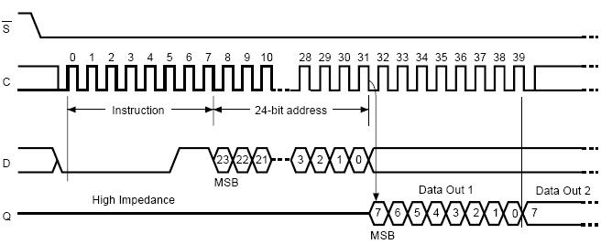
可以分解为两个spi_ transfer一个是写命令，另一个是读数据。具体实现参见m25p80.c中的m25p80_read函数。下面内容摘取之此函数。
structspi_transfer t[2]; //定义了两个spi_transfer
structspi_message m; //定义了一个spi_message
spi_message_init(&m);//初始化其transfers链表
t[0].tx_buf = flash->command;
t[0].len = CMD_SIZE + FAST_READ_DUMMY_BYTE;//定义第一个transfer的写指针和长度
spi_message_add_tail(&t[0],&m);//添加到spi_message
t[1].rx_buf = buf;
t[1].len = len; //定义第二个transfer的读指针和长度
spi_message_add_tail(&t[1],&m); //添加到spi_message
flash->command[0] = OPCODE_READ;
flash->command[1] = from >> 16;
flash->command[2] = from >> 8;
flash->command[3] = from; //初始化前面写buf的内容
spi_sync(flash->spi,&m); //调用spi_master发送spi_message
//spi_sync为同步方式发送，还可以用spi_async异步方式，那样的话，需要设置回调完成函数。
另外你也可以选择一些封装好的更容易使用的函数，这些函数可以在include/linux/spi/spi.h文件中找到，如：
extern int spi_write_then_read(struct spi_device*spi,
const u8 *txbuf, unsigned n_tx,
u8 *rxbuf, unsigned n_rx);
这篇博文就到这了，下篇给出一个针对m25p10完整的驱动程序。

四、m25p10驱动测试
目标：在华清远见的FS_S5PC100平台上编写一个简单的spi驱动模块，在probe阶段实现对m25p10的ID号探测、flash擦除、flash状态读取、flash写入、flash读取等操作。代码已经经过测试，运行于2.6.35内核。理解下面代码需要参照m25p10的芯片手册。其实下面的代码和处理器没有太大关系，这也是spi子系统的分层特点。
view plain
- #include <linux/platform_device.h>
- #include <linux/spi/spi.h>
- #include <linux/init.h>
- #include <linux/module.h>
- #include <linux/device.h>
- #include <linux/interrupt.h>
- #include <linux/mutex.h>
- #include <linux/slab.h> // kzalloc
- #include <linux/delay.h>

- #define FLASH_PAGE_SIZE 256

- /* Flash Operating Commands */
- #define CMD_READ_ID 0x9f
- #define CMD_WRITE_ENABLE 0x06
- #define CMD_BULK_ERASE 0xc7
- #define CMD_READ_BYTES 0x03
- #define CMD_PAGE_PROGRAM 0x02
- #define CMD_RDSR 0x05

- /* Status Register bits. */
- #define SR_WIP 1 /* Write in progress */
- #define SR_WEL 2 /* Write enable latch */

- /* ID Numbers */
- #define MANUFACTURER_ID 0x20
- #define DEVICE_ID 0x1120

- /* Define max times to check status register before we give up. */
- #define MAX_READY_WAIT_COUNT 100000
- #define CMD_SZ 4

- struct m25p10a {
- struct spi_device *spi;
- struct mutex lock;
- char erase_opcode;
- char cmd[ CMD_SZ ];
- };

- /*
- * Internal Helper functions
- */

- /*
- * Read the status register, returning its value in the location
- * Return the status register value.
- * Returns negative if error occurred.
- */
- static int read_sr(struct m25p10a *flash)
- {
- ssize_t retval;
- u8 code = CMD_RDSR;
- u8 val;

- retval = spi_write_then_read(flash->spi, &code, 1, &val, 1);

- if (retval < 0) {
- dev_err(&flash->spi->dev, "error %d reading SR\n",
- (int) retval);
- return retval;
- }

- return val;
- }

- /*
- * Service routine to read status register until ready, or timeout occurs.
- * Returns non-zero if error.
- */
- static int wait_till_ready(struct m25p10a *flash)
- {
- int count;
- int sr;

- /* one chip guarantees max 5 msec wait here after page writes,
- * but potentially three seconds (!) after page erase.
- */
- for (count = 0; count < MAX_READY_WAIT_COUNT; count++) {
- if ((sr = read_sr(flash)) < 0)
- break;
- else if (!(sr & SR_WIP))
- return 0;

- /* REVISIT sometimes sleeping would be best */
- }
- printk( "in (%s): count = %d\n", count );

- return 1;
- }

- /*
- * Set write enable latch with Write Enable command.
- * Returns negative if error occurred.
- */
- static inline int write_enable( struct m25p10a *flash )
- {
- flash->cmd[0] = CMD_WRITE_ENABLE;
- return spi_write( flash->spi, flash->cmd, 1 );
- }

- /*
- * Erase the whole flash memory
- *
- * Returns 0 if successful, non-zero otherwise.
- */
- static int erase_chip( struct m25p10a *flash )
- {
- /* Wait until finished previous write command. */
- if (wait_till_ready(flash))
- return -1;

- /* Send write enable, then erase commands. */
- write_enable( flash );
- flash->cmd[0] = CMD_BULK_ERASE;
- return spi_write( flash->spi, flash->cmd, 1 );
- }

- /*
- * Read an address range from the flash chip. The address range
- * may be any size provided it is within the physical boundaries.
- */
- static int m25p10a_read( struct m25p10a *flash, loff_t from,
- size_t len, char *buf )
- {
- int r_count = 0, i;

- flash->cmd[0] = CMD_READ_BYTES;
- flash->cmd[1] = from >> 16;
- flash->cmd[2] = from >> 8;
- flash->cmd[3] = from;

- #if 1
- struct spi_transfer st[2];
- struct spi_message msg;

- spi_message_init( &msg );
- memset( st, 0, sizeof(st) );

- flash->cmd[0] = CMD_READ_BYTES;
- flash->cmd[1] = from >> 16;
- flash->cmd[2] = from >> 8;
- flash->cmd[3] = from;

- st[ 0 ].tx_buf = flash->cmd;
- st[ 0 ].len = CMD_SZ;
- spi_message_add_tail( &st[0], &msg );

- st[ 1 ].rx_buf = buf;
- st[ 1 ].len = len;
- spi_message_add_tail( &st[1], &msg );

- mutex_lock( &flash->lock );

- /* Wait until finished previous write command. */
- if (wait_till_ready(flash)) {
- mutex_unlock( &flash->lock );
- return -1;
- }

- spi_sync( flash->spi, &msg );
- r_count = msg.actual_length - CMD_SZ;
- printk( "in (%s): read %d bytes\n", __func__, r_count );
- for( i = 0; i < r_count; i++ ) {
- printk( "0x%02x\n", buf[ i ] );
- }

- mutex_unlock( &flash->lock );
- #endif

- return 0;
- }

- /*
- * Write an address range to the flash chip. Data must be written in
- * FLASH_PAGE_SIZE chunks. The address range may be any size provided
- * it is within the physical boundaries.
- */
- static int m25p10a_write( struct m25p10a *flash, loff_t to,
- size_t len, const char *buf )
- {
- int w_count = 0, i, page_offset;
- struct spi_transfer st[2];
- struct spi_message msg;
- #if 1
- if (wait_till_ready(flash)) { //读状态，等待ready
- mutex_unlock( &flash->lock );
- return -1;
- }
- #endif
- write_enable( flash ); //写使能

- spi_message_init( &msg );
- memset( st, 0, sizeof(st) );

- flash->cmd[0] = CMD_PAGE_PROGRAM;
- flash->cmd[1] = to >> 16;
- flash->cmd[2] = to >> 8;
- flash->cmd[3] = to;

- st[ 0 ].tx_buf = flash->cmd;
- st[ 0 ].len = CMD_SZ;
- spi_message_add_tail( &st[0], &msg );

- st[ 1 ].tx_buf = buf;
- st[ 1 ].len = len;
- spi_message_add_tail( &st[1], &msg );

- mutex_lock( &flash->lock );

- /* get offset address inside a page */
- page_offset = to % FLASH_PAGE_SIZE;

- /* do all the bytes fit onto one page? */
- if( page_offset + len <= FLASH_PAGE_SIZE ) { // yes
- st[ 1 ].len = len;
- printk("%d, cmd = %d\n", st[ 1 ].len, *(char *)st[0].tx_buf);
- //while(1)
- {
- spi_sync( flash->spi, &msg );
- }
- w_count = msg.actual_length - CMD_SZ;
- }
- else { // no
- }
- printk( "in (%s): write %d bytes to flash in total\n", __func__, w_count );
- mutex_unlock( &flash->lock );
- return 0;
- }

- static int check_id( struct m25p10a *flash )
- {
- char buf[10] = {0};
- flash->cmd[0] = CMD_READ_ID;
- spi_write_then_read( flash->spi, flash->cmd, 1, buf, 3 );
- printk( "Manufacture ID: 0x%x\n", buf[0] );
- printk( "Device ID: 0x%x\n", buf[1] | buf[2] << 8 );
- return buf[2] << 16 | buf[1] << 8 | buf[0];
- }

- static int m25p10a_probe(struct spi_device *spi)
- {
- int ret = 0;
- struct m25p10a *flash;
- char buf[ 256 ];
- printk( "%s was called\n", __func__ );
- flash = kzalloc( sizeof(struct m25p10a), GFP_KERNEL );
- if( !flash ) {
- return -ENOMEM;
- }
- flash->spispi = spi;
- mutex_init( &flash->lock );
- /* save flash as driver's private data */
- spi_set_drvdata( spi, flash );

- check_id( flash ); //读取ID
- #if 1
- ret = erase_chip( flash ); //擦除
- if( ret < 0 ) {
- printk( "erase the entirely chip failed\n" );
- }
- printk( "erase the whole chip done\n" );
- memset( buf, 0x7, 256 );
- m25p10a_write( flash, 0, 20, buf); //0地址写入20个7
- memset( buf, 0, 256 );
- m25p10a_read( flash, 0, 25, buf ); //0地址读出25个数
- #endif
- return 0;
- }

- static int m25p10a_remove(struct spi_device *spi)
- {
- return 0;
- }

- static struct spi_driver m25p10a_driver = {
- .probe = m25p10a_probe,
- .remove = m25p10a_remove,
- .driver = {
- .name = "m25p10a",
- },
- };

- static int __init m25p10a_init(void)
- {
- return spi_register_driver(&m25p10a_driver);
- }

- static void __exit m25p10a_exit(void)
- {
- spi_unregister_driver(&m25p10a_driver);
- }

- module_init(m25p10a_init);
- module_exit(m25p10a_exit);

- MODULE_DESCRIPTION("m25p10a driver for FS_S5PC100");
- MODULE_LICENSE("GPL");

